Capacitive proximity sensors

**1- General description**: Capacitive proximity sensors are non-contact devices that can detect the presence or absence of virtually any object regardless of material. They utilize the electrical property of capacitance and the change of capacitance based on a change in the electrical field around the active face of the sensor. Capacitive proximity sensors operate by noting a change in the capacitance read by the sensor. A typical capacitor consists of two conductive elements (sometimes called plates) separated by some kind of insulating material that can be one of many different types including ceramic, plastic, paper, or other materials.

**2 - Construction:** A capacitive sensor acts like a simple capacitor. A metal plate in the sensing face of the sensor is electrically connected to an internal oscillator circuit and the target to be sensed acts as the second plate of the capacitor.

**3 – Principle of operation:**

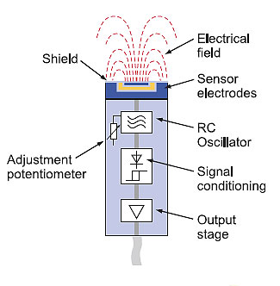

Figure a

The way a capacitive proximity sensor works is that one of the conductive elements, or plates, is inside the sensor itself while the other one is the object to be sensed. The internal plate is connected to an oscillator circuit that generates an electric field. The air gap between the internal plate and the external object serves as the insulator or dielectric material. When an object is present, that changes the capacitance value and registers as the presences of the object.

Figure a shows the internal construction of a capacitive proximity sensor with the internal plate connected to the oscillator (sensor electrodes), and the other being the sensed object, which is detected within the electric field.

**4 - Applications:**

* The ability to detect nonmetallic objects.
* The ability to detect small lightweight objects that cannot be picked up by mechanical limit switches.
* A solid state output that does not bounce its contact signal.
* A high switching rate that provides quick reaction in object counting applications.
* The ability to detect liquid targets through certain barriers.
* A long operational lifespan.

**5 - Advantages of capacitive sensing**

* The ability to detect nonmetallic objects.
* The ability to detect small lightweight objects that cannot be picked up by mechanical limit switches.
* A solid state output that does not bounce its contact signal.
* A high switching rate that provides quick reaction in object counting applications.
* The ability to detect liquid targets through certain barriers.
* A long operational lifespan.